# AB Integrals and Their Applications

## Multiple Choice

1. (calculator not allowed) 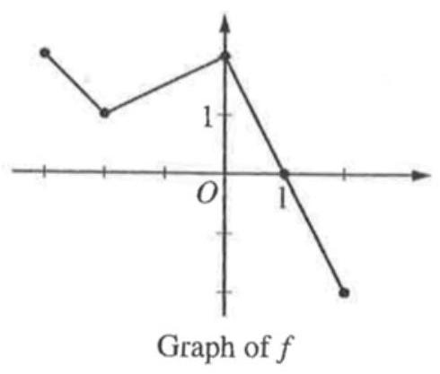 The graph of a piecewise linear function $f\left(x\right)$, for $-3≤x≤2$, is shown above. What is the value of $\int_{-2}^{2}{\left(f\left(x\right)+2\right)}dx$?
   1. 5
   2. 6.5
   3. 11
   4. 12.5
2. (calculator not allowed) Let $f\left(x\right)$ be a continuous function. Using the substitution $u=3x+1$, the integral $\int_{1}^{4}{f}\left(3x+1\right)dx$ is equal to which of the following?
$\int_{1}^{4}{f}\left(u\right)du$

$\frac{1}{3}\int_{1}^{4}{f}\left(u\right)du$

$3\int_{4}^{13}{f}\left(u\right)du$

$\frac{1}{3}\int_{4}^{13}{f}\left(u\right)du$

3. (calculator not allowed)
$$∫\frac{1}{x^{2}}dx=$$

$lnx^{2}+C$

$-lnx^{2}+C$

$x^{-1}+C$

$-x^{-1}+C$

$-2x^{-3}+C$

4. (calculator not allowed) Which of the following integral expressions is equal to $\lim_{n→∞}\sum_{k=1}^{n}{\left({\left(1+\frac{2k}{n}\right)}^{2}⋅\frac{1}{n}\right)}$?
$\int_{0}^{1}{{\left(1+2x\right)}^{2}}dx$

$\int_{0}^{2}{{\left(1+x\right)}^{2}}dx$

$\int_{1}^{3}{x^{2}}dx$

$\frac{1}{2}\int_{0}^{2}{x^{2}}dx$

5. (calculator not allowed) $f\left(x\right)=\left\{\begin{matrix}x\text{ for }x<2 \\ 3\text{ for }x≥2\end{matrix}\right.$ If $f$ is the function defined above, then $\int_{-1}^{4}{f}\left(x\right)dx$ is
 $\frac{9}{2}$

 $\frac{15}{2}$

 $\frac{17}{2}$

1. undefined
6. (calculator not allowed)
$$\int_{0}^{3}{\frac{x^{2}+4x+5}{x+3}}dx=$$

$\frac{84}{63}$

$3+2ln2$

$\frac{15}{2}+2ln2$

$\frac{15}{2}+2ln3$

7. (calculator not allowed)
$$∫\frac{1}{x^{2}+6x+13}dx=$$

$\frac{1}{2}arctan\frac{\left(x+3\right)}{2}+C$

$\frac{1}{\frac{x^{3}}{3}+3x^{2}+13x}+C$

$ln\left|x^{2}+6x+13\right|+C$

$2arctan\frac{\left(x+3\right)}{2}+C$

8. (calculator not allowed) At time $t$, a population of bacteria grows at a rate of $5e^{0.2t}+4t$ grams per day, where $t$ is measured in days. By how many grams has the population grown from time $t=0$ to $t=10$ days?
$5e^{2}+40$

$5e^{2}+195$

$25e^{2}+175$

$25e^{2}+375$

9. (calculator not allowed) Which of the following limits is equal to $\int_{3}^{7}{x^{3}}dx$?
$\lim_{n→∞}\sum_{k=1}^{n}{\left({\left(3+\frac{k}{n}\right)}^{3}⋅\frac{1}{n}\right)}$

$\lim_{n→∞}\sum_{k=1}^{n}{\left({\left(3+\frac{k}{n}\right)}^{3}⋅\frac{4}{n}\right)}$

$\lim_{n→∞}\sum_{k=1}^{n}{\left({\left(3+\frac{4k}{n}\right)}^{3}⋅\frac{1}{n}\right)}$

$\lim_{n→∞}\sum_{k=1}^{n}{\left({\left(3+\frac{4k}{n}\right)}^{3}⋅\frac{4}{n}\right)}$

10. (calculator not allowed) $∫e^{x}cos\left(e^{x}+1\right)dx=$
$sin\left(e^{x}+1\right)+C$

$e^{x}sin\left(e^{x}+1\right)+C$

$e^{x}sin\left(e^{x}+x\right)+C$

$\frac{1}{2}\cos^{2}\left(e^{x}+1\right)+C$

11. (calculator not allowed) Using the substitution $u=\sqrt{x}$, the integral $\int_{1}^{9}{\frac{sin\sqrt{x}}{\sqrt{x}}}dx$ is equal to which of the following?
$\frac{1}{2}\int_{1}^{3}{sin}udu$

$2\int_{1}^{3}{\frac{sinu}{u}}du$

$2\int_{1}^{3}{sin}udu$

$2\int_{1}^{9}{sin}udu$

12. (calculator not allowed) 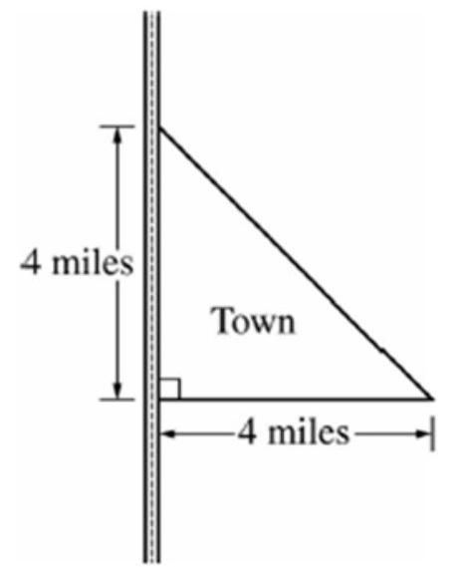 The right triangle shown in the figure represents the boundary of a town that is bordered by a highway. The population density of the town at a distance of $x$ miles from the highway is modeled by $D\left(x\right)=\sqrt{x+1}$, where $D\left(x\right)$ is measured in thousands of people per square mile. According to the model, which of the following expressions gives the total population, in thousands, of the town?
$\int_{0}^{4}{\sqrt{x+1}}dx$

$\int_{0}^{4}{8}\sqrt{x+1}dx$

$\int_{0}^{4}{x}\sqrt{x+1}dx$

$\int_{0}^{4}{\left(4-x\right)}\sqrt{x+1}dx$

13. (calculator not allowed) If $f$ is the function defined $$f\left(x\right)=\left\{\begin{matrix}\frac{\left|x-1\right|}{x-1} & ,x≠1 \\ 1 & ,x=1\end{matrix}\right.$$ then $\int_{-1}^{4}{f}\left(x\right)dx$ is
    1. 1
    2. 2
    3. 5
    4. nonexistent
14. (calculator not allowed) $\int_{1}^{2}{\frac{x^{2}+6x+6}{x+1}}dx=$
 $1+ln\frac{3}{2}$

   1. 6.5
$6.5+ln\frac{3}{2}$

$6.5+ln6$

15. (calculator not allowed) $∫\frac{x}{x^{2}-4}dx=$
$\frac{-1}{4{\left(x^{2}-4\right)}^{2}}+C$

$\frac{1}{2\left(x^{2}-4\right)}+C$

$\frac{1}{2}ln\left|x^{2}-4\right|+C$

$2ln\left|x^{2}-4\right|+C$

$\frac{1}{2}arctan\left(\frac{x}{2}\right)+C$

16. (calculator not allowed) $\int_{1}^{e}{\frac{x^{2}-1}{x}}dx=$
$e-\frac{1}{e}$

$e^{2}-e$

$\frac{e^{2}}{2}-e+\frac{1}{2}$

$e^{2}-2$

$\frac{e^{2}}{2}-\frac{3}{2}$

17. (calculator not allowed) $\int_{0}^{1}{\frac{arctanx}{1+x^{2}}}dx==$
 $\frac{π}{4}$

 $\frac{π^{2}}{32}$

 $\frac{π^{2}}{16}$

 1. 1
18. (calculator allowed) A rain barrel collects water off the roof of a house during three hours of heavy rainfall. The height of the water in the barrel increases at the rate of $r\left(t\right)=4t^{3}e^{-1.5t}$ feet per hour where $t$ is the time in hours since the rain began. At time $t=1$ hour, the height of water is 0.75 foot. What is the height of water in the barrel at time $t=2$ hours?
$1.361ft$

$1.500ft$

$1.672ft$

$2.111ft$

19. (calculator allowed) The function $g$ is continuous on the closed interval $\left[2,10\right]$. If $\int_{2}^{10}{g}\left(x\right)dx=63$ and $\int_{10}^{5}{\frac{1}{2}}g\left(x\right)dx=-16$, then $\int_{2}^{5}{2}g\left(x\right)dx=$
    1. 31
    2. 62
    3. 95
    4. 190
20. (calculator not allowed) A pizza, heated to a temperature of 350 degrees Fahrenheit ( $​^{∘}F$), is taken out of an oven and placed in a ${75}^{∘}F$ room at time $t=0$ minutes. The temperature of the pizza is changing at a rate of $-110e^{-0.4t}$ degrees Fahrenheit per minute. Which of the following is the best interpretation of $\int_{0}^{30}{-}110e^{-0.4t}dt$?
    1. The average temperature of the pizza, in degrees Fahrenheit, over the 30 minutes time interval after it was taken out of the oven.
    2. Temperature of the pizza, in degrees Fahrenheit, 30 minutes after it was taken out of the oven.
    3. The rate at which the temperature of the pizza is changing, in degrees Fahrenheit per minute, 30 minutes after it was taken out of the oven.
    4. The change in the temperature of the pizza, in degrees Fahrenheit, over the 30 minutes time interval after it was taken out of the oven.
21. (calculator allowed) What is the average value of $y=\frac{cosx}{x^{2}+x+2}$ on the closed interval $\left[-1,3\right]$?
    1. -0.085
    2. 0.090
    3. 0.183
    4. 0.244
    5. 0.732
22. (calculator allowed) On the closed interval $\left[2,4\right]$, which of the following could be the graph of a function $f$ with the property that $\frac{1}{4-2}\int_{2}^{4}{f}\left(t\right)dt=1$?
    1. 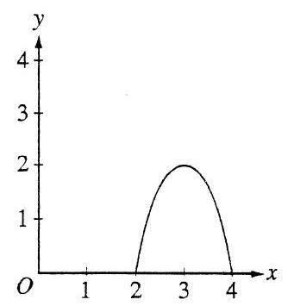
    2. 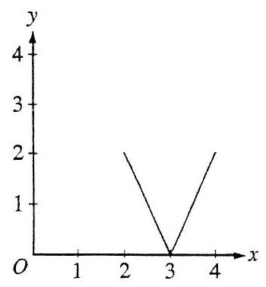
    3. 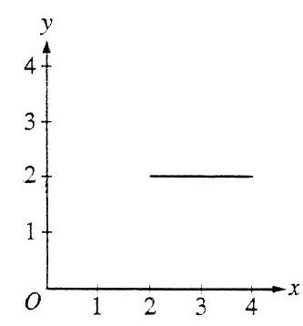
    4. 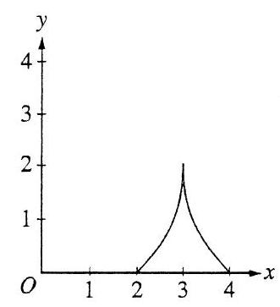
    5. 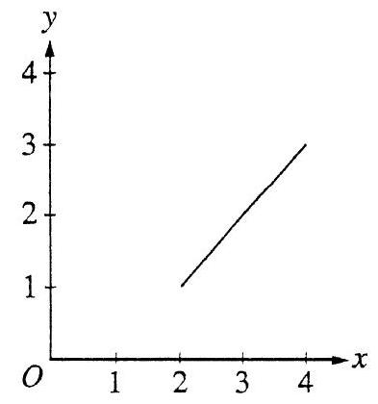
23. (calculator not allowed) If $f$ is a continuous function and if $F^{'}\left(x\right)=f\left(x\right)$ for all real numbers $X$, then $\int_{1}^{3}{f}\left(2x\right)dx=$

$2F\left(3\right)-2F\left(1\right)$

$\frac{1}{2}F\left(3\right)-\frac{1}{2}F\left(1\right)$

$2F\left(6\right)-2F\left(2\right)$

$F\left(6\right)-F\left(2\right)$

$\frac{1}{2}F\left(6\right)-\frac{1}{2}F\left(2\right)$